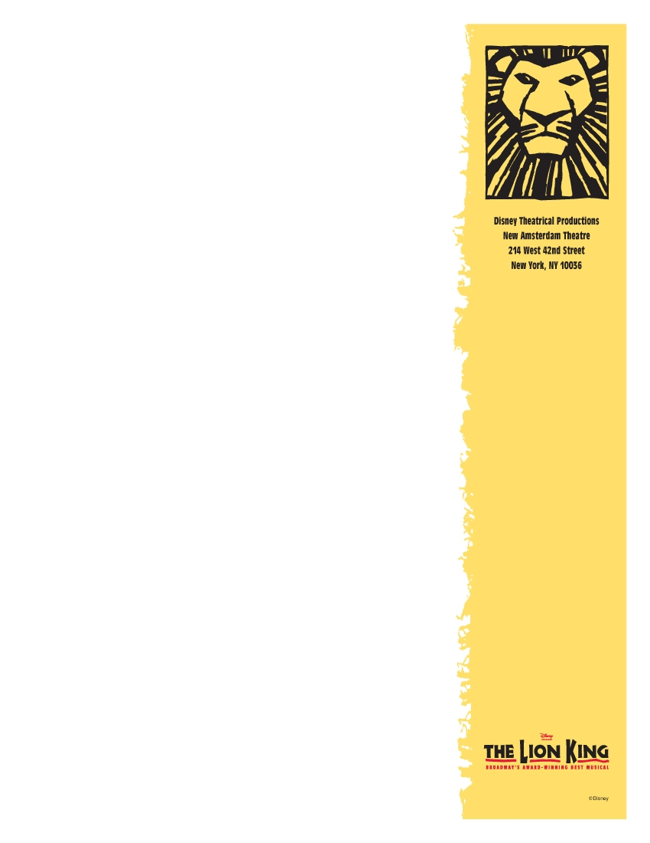

FUN FACTS

Masks & Puppets
• There are more than 200 puppets in the show, including rod puppets, shadow puppets, and full-sized puppets.

• There are 25 kinds of animals, birds, fish, and insects represented in the show.

• There are 12 bird kites in the opening number of Act II, “One By One”

• It took 17,000 hours to build the puppets and masks.

• Mufasa’s mask weighs 11 ounces.

- Scar’s mask weighs 9 ounces.

- The most complicated set piece is Pride Rock. It is a battery powered
piece which is 18’ long at its fullest onstage and compresses to 8’ when it is offstage.

• The tallest animals in the show are the 18-foot exotic giraffes seen in “I JustCan’t Wait to Be King.”

• The tiniest animal is the trick mouse at the end of Scar’s cane: 5”.

• The longest animal is an elephant: 13’ long, 11’ 3” high, and 9’ wide at the ears. It collapses to 34” wide to go down the aisle in the theatres.

• 300’ of carbon fiber and 750 pounds of silicone rubber were used to make the masks.

• The Timon puppet weighs 15 pounds.

• The show uses 18 trucks to transport the production’s puppets, set pieces and other materials from city to city. 14 of the trucks are 53’ semi-trailers.

- Number of wigs in the show: 49

- There are four African dialects spoken in the show: Swahili, Zulu, Ghosa and Soweto

Costumes
• The Grasslands headdresses use 3,000 stalks of grass per year.

• There are over 100 ants on the Ant-Hill Lady.

• Number of hyenas in the show: 39.

• Number of wildebeests in the show: 52.

Miscellaneous
• There are 134 people directly involved with the daily production of the show—49 cast members, 19 wardrobe people, 18 musicians, 11 carpenters, 10 electricians, 5 hair/make-up artists, 3 puppet craftsmen, 4 props people, 4 Stage Managers, 3 sound people, 2 creative associates, 2 Company Managers, 2 Merchandise Associates, 1 Physical Therapist and 1 Tutor.

• Lighting Designer Donald Holder used nearly 700 lighting instruments to create the show’s lighting plot.

