Popejoy Hall   
Social Narrative

Wind in the Willows

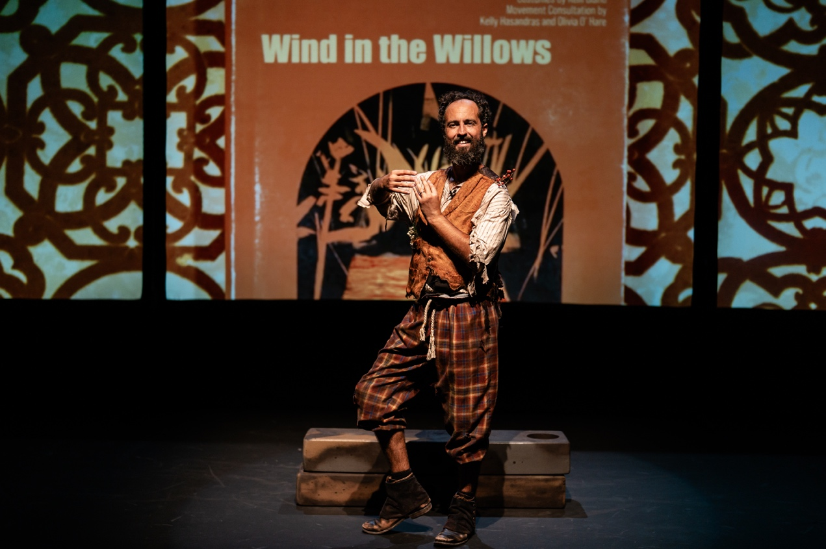

My Time at Popejoy Hall

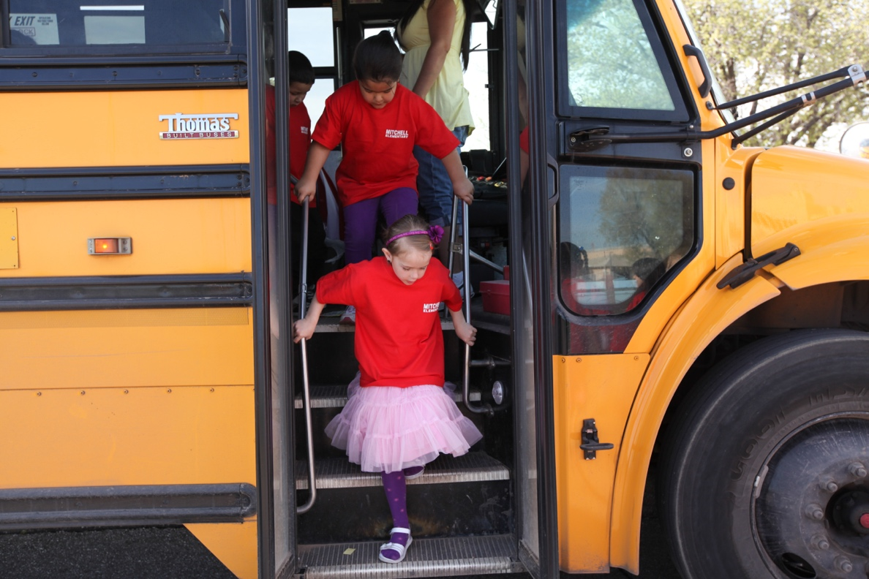

I will ride the bus from my school to Popejoy Hall.

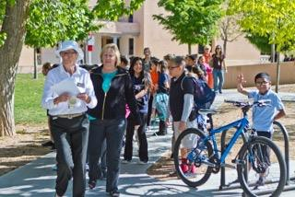

I will take a short walk from where the bus drops off my class to the theater.

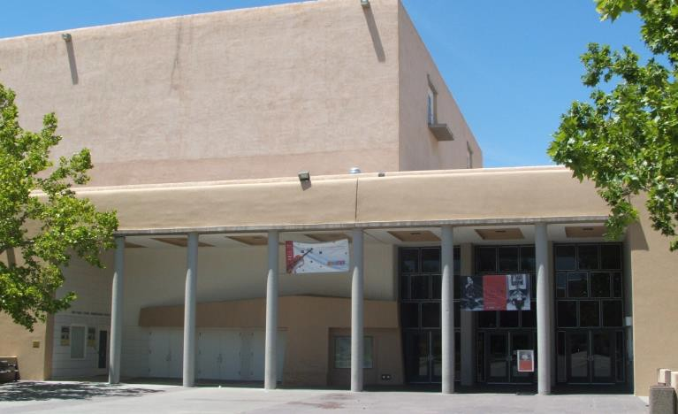

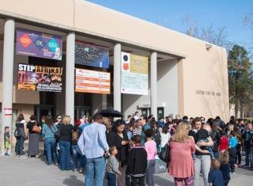

When I get to the front of the building I might have to wait in a line, but it is okay, I can play with my fidget toy while I wait to find my seat.

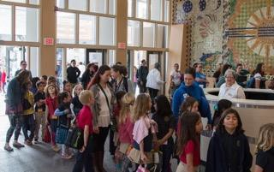

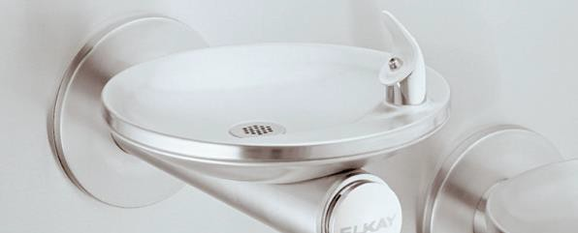 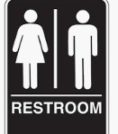

Before I find my seat, I can use the restroom and get a drink of water.

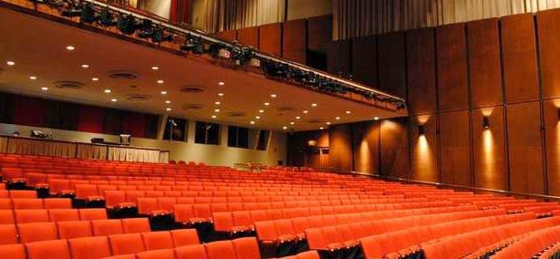 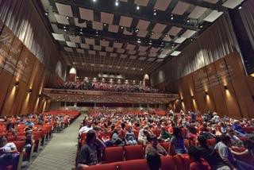

I will then walk into the theater. An adult will help me find my seat.

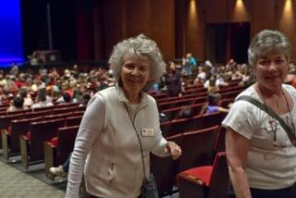

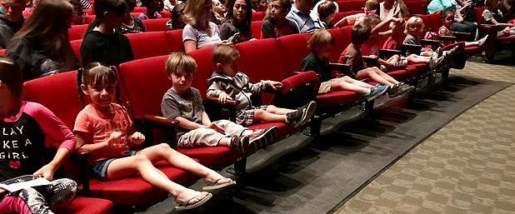

I will sit in my seat and wait for the show to start.

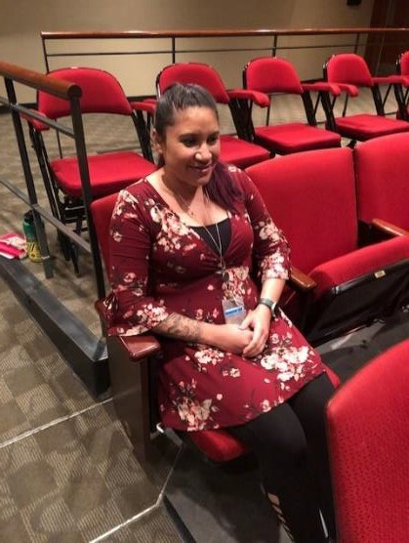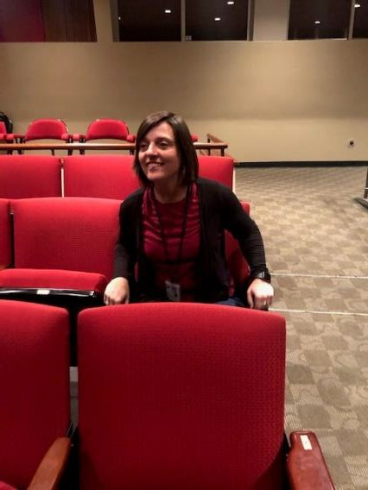

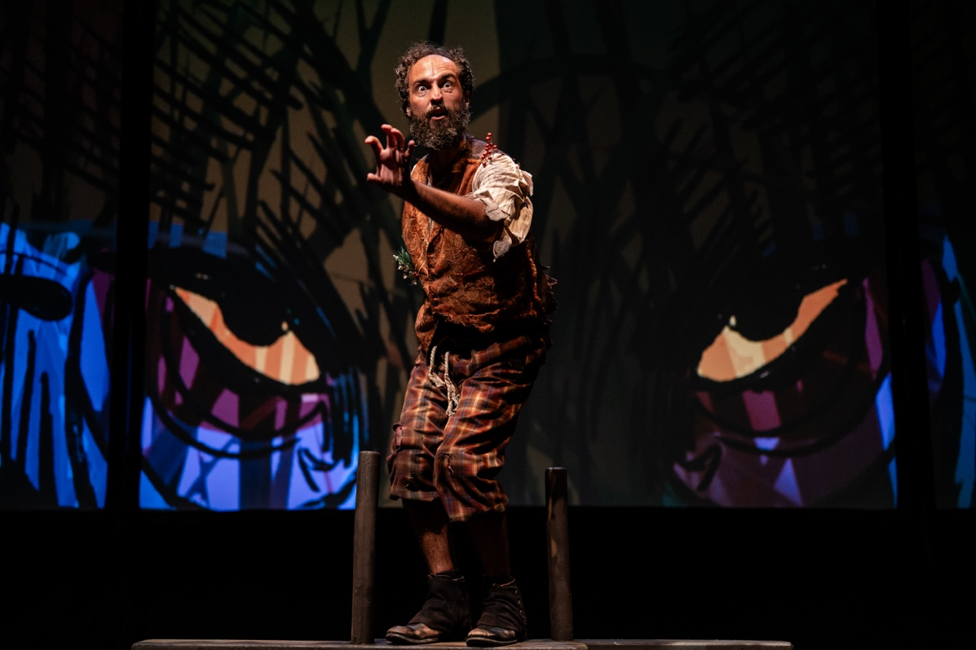

When the music starts, the lights will be turned down and the show will start.

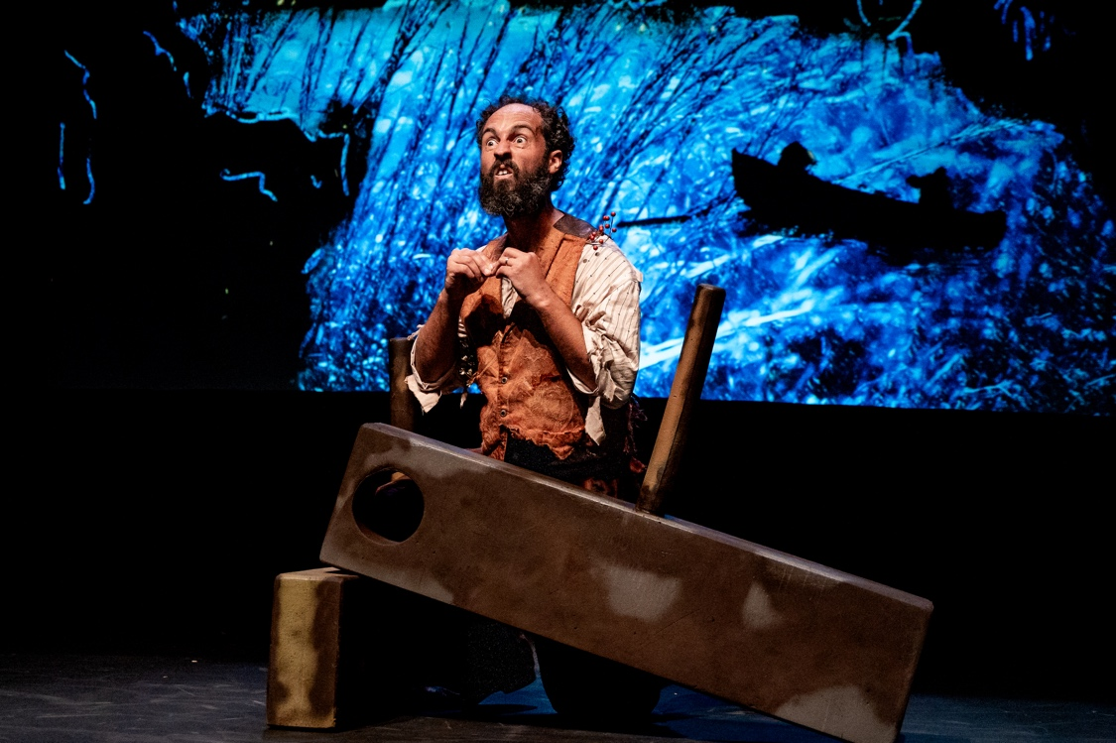

When the show starts, I will try to stay in my seat. If I feel scared, I can cover my ears and squeeze my fidget.

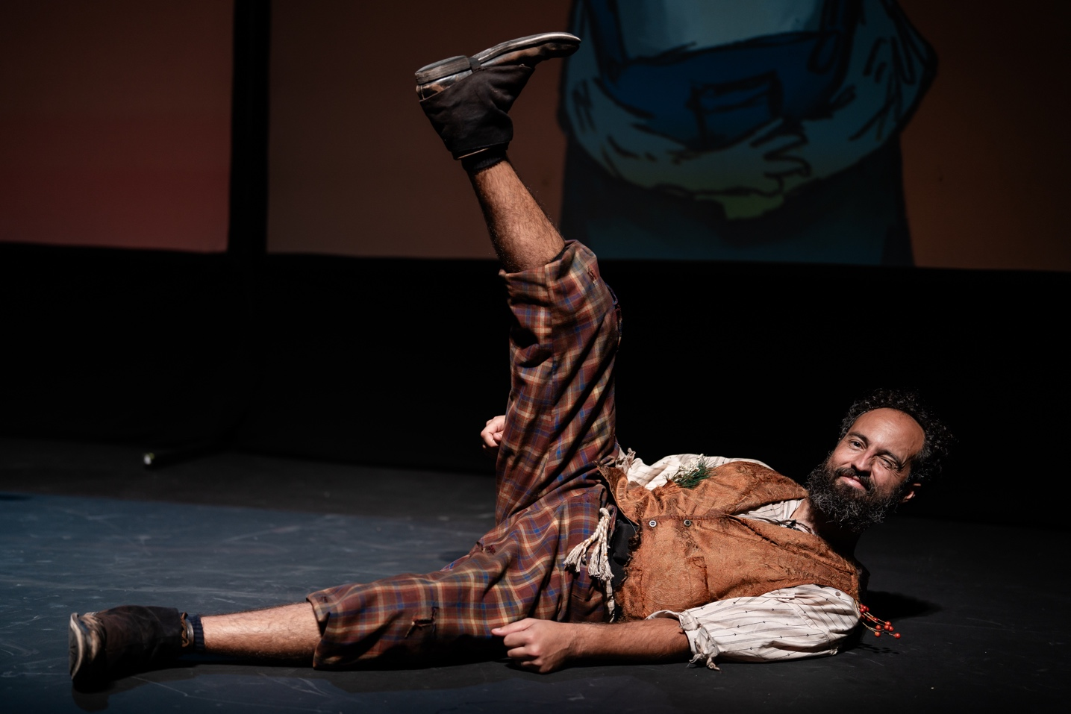

After different parts of the show, people around me will clap. If the clapping is too loud, I can cover my ears.

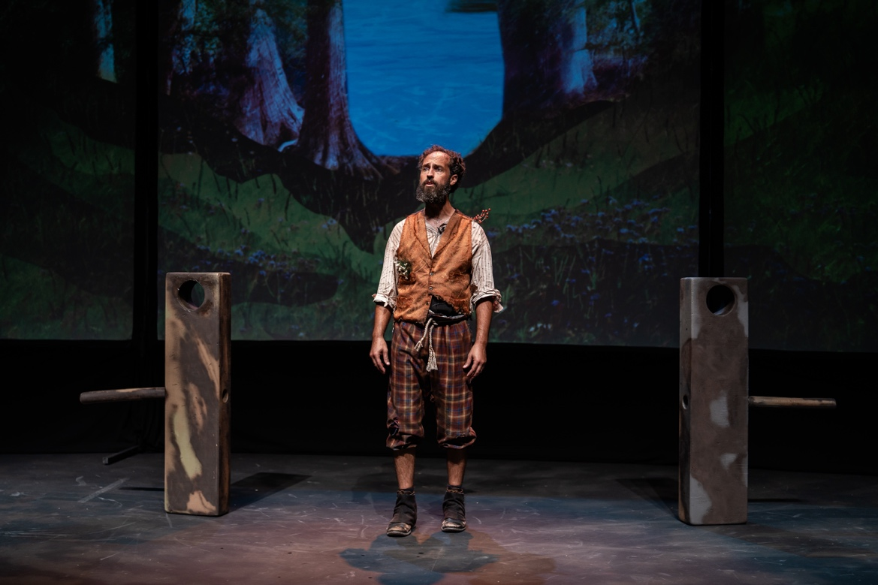

At the end of the show, people will clap, and I will then be able to get up and stretch my legs.

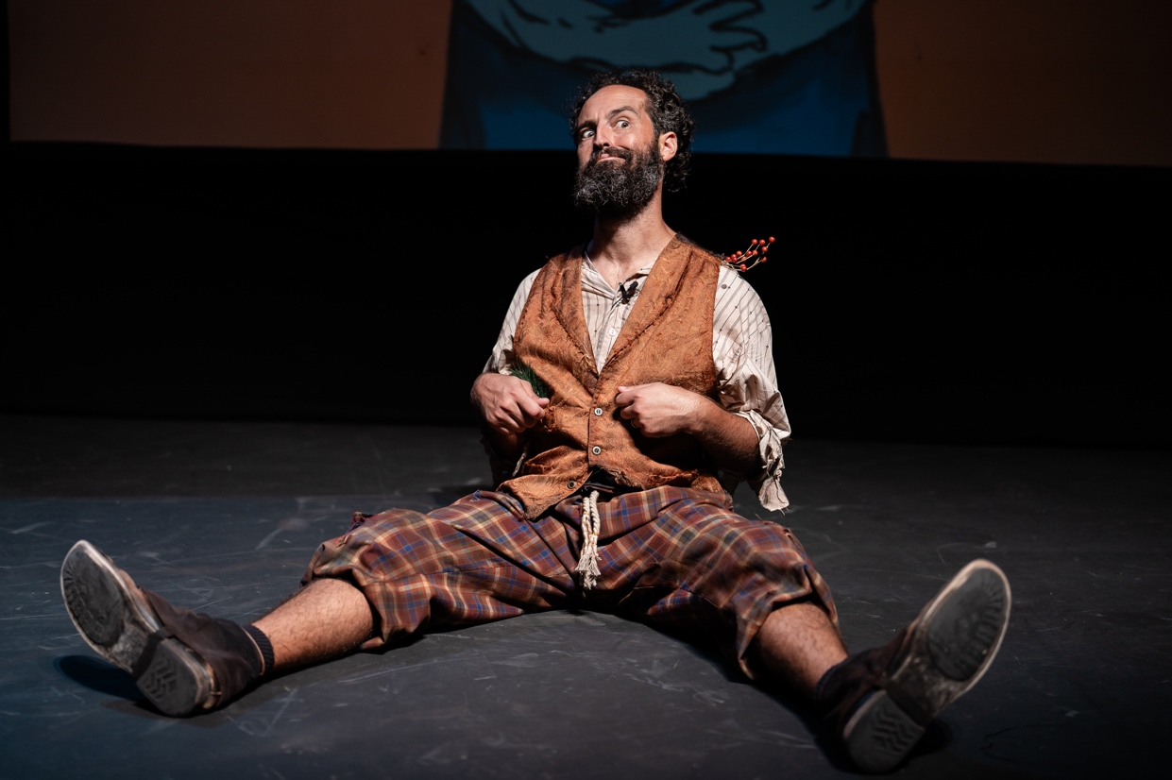

Sometimes being quiet and staying in my seat can be hard, but I will try my best. Going to the theater is FUN!